  - First access Set-Up
Your content management system can be access at http://yourwebsite.com/administrator/
On first access your username is admin and password is password.

Create Sections, Categories, SubCategories
Using the Admin interface:
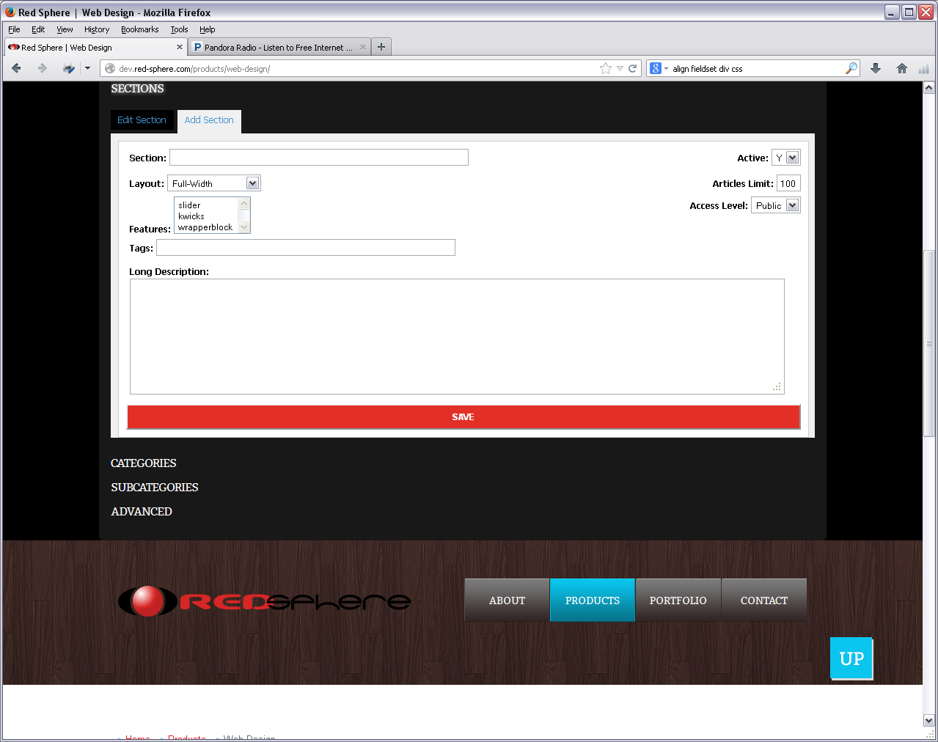
You can set these variables per each:
- Section name
- Choose layout (Refer to “new page layout.docx”)
- Set features (Refer to “How to Add New Feature.docx”)
- Tags: SEO tags
- Long Description: SEO Description
- Articles limit
Time: 10 minutes / each

